**Pretest**

**i)** We conducted 2 stages of pre testing for the sake of having two different

data the describes how well we did changing our questionnaire

stage 1 was conducted on 13 interviewees ,5 of which was not recorded

ii) stage2 was conducted no 5 interviewees and was recorded

**interview 1**

1-edit the specs question to make it closed-ended, most people will not fill it if it open-ended

2-the income question can be range form 1 to 100 to make it easier to be answered

3-question “how important is this attributes to you : without cable” ,make it more clearer

4-question “If you had the chance to buy a device again, what would you prefer?” ,is not clear

**interview 2**

1- the interviewee was asked about point 2,3 from interviewee one and didn’t agree with them

2- edit the specs question to make it closed-ended, most people will not fill it if it open-ended

3-question “If you had the chance to buy a device again, what would you prefer?” ,is not clear

**interview 3**

1- the income question can be specified with a yearly salary range

2- question “how important is this attributes to you :multiple monitors” , make it clearer

3- question ”how many hours do you spend on: Self study ”,make it Self study(course etc)

4- edit the specs question to make it closed-ended, most people will not fill it if it open-ended

5-the survey is small ?

**interview 4**

1- the income question can be range form 1 to 100 to make it easier to be answered

2-question “If you had the chance to buy a device again, what would you prefer?” ,is not clear

**interview 5**

1- question “ the main usage of your device ?”, have a typo in answers

2- last question “express your point of view”, some people will be too lazy to fill it

3- question “how important is this attributes to you :” make its range 1 to 5 instead of 0 to 4

**interview 6**

1- add a question for a bunch of pcs asking them which device can you financially buy

2-edit the specs question to make it closed-ended, most people will not fill it if it open-ended

3-question “If you had the chance to buy a device again, what would you prefer?” ,is not clear

**interview 7**

1-question “If you had the chance to buy a device again, what would you prefer?” ,is not clear

2-less open ended questions in general

**interview 8**

1-translate some hard-to-understand words

2-question “If you had the chance to buy a device again, what would you prefer?” ,is not clear

3-edit the specs question to make it closed-ended, most people will not fill it if it open-ended

**At this point most of the interviewee was just**

**addressing the same points**

Here is the other 5 interviewee points all together

**1-**Id question:

• make it optional.

**2-**

• add a range

• change the paraphrase to make it clearer the question is for family income

**3-**

• is not clear

• make it mcq with "other" option

**4-**

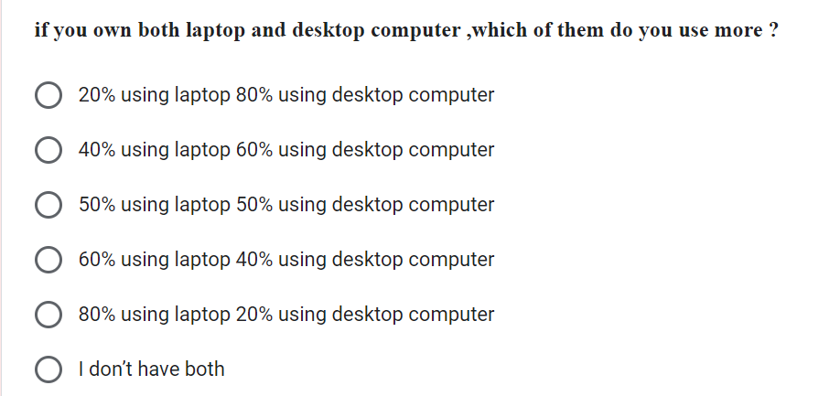

•Change the choices to (mostly , sometimes , more than ,less than)

**5-**

• Add another question about "total" usage, not only the "main usage", and it should be

cheek box.

**6-**

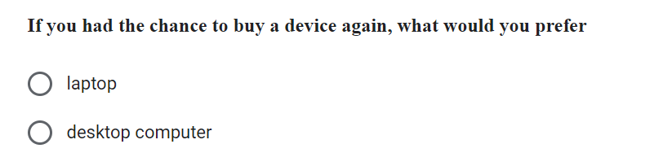

• add "tablet" in choices.

**7-**

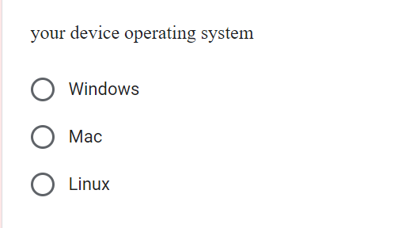

• add "other."

**8-**

• change "mostly any game" to "high processing tasks"

**9-**

• change the range to (1-5)

**10-**

• Add "hours" word in question to make it clear.

• Delete the ranges in the question statement.

• Add a question about "communication"

**11-**

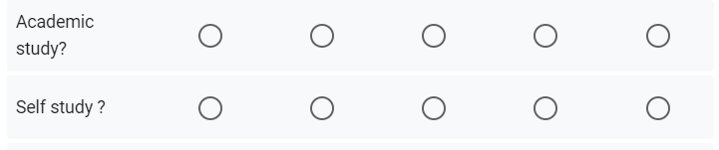

• Change it to one question, and change it to "education."

**12-**

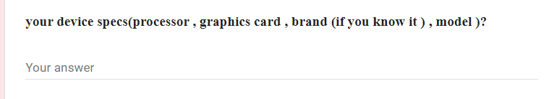

• Should be optional.

**13-**

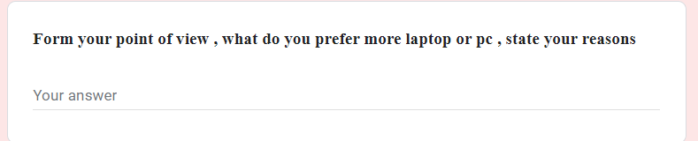

• change the paraphrase the question